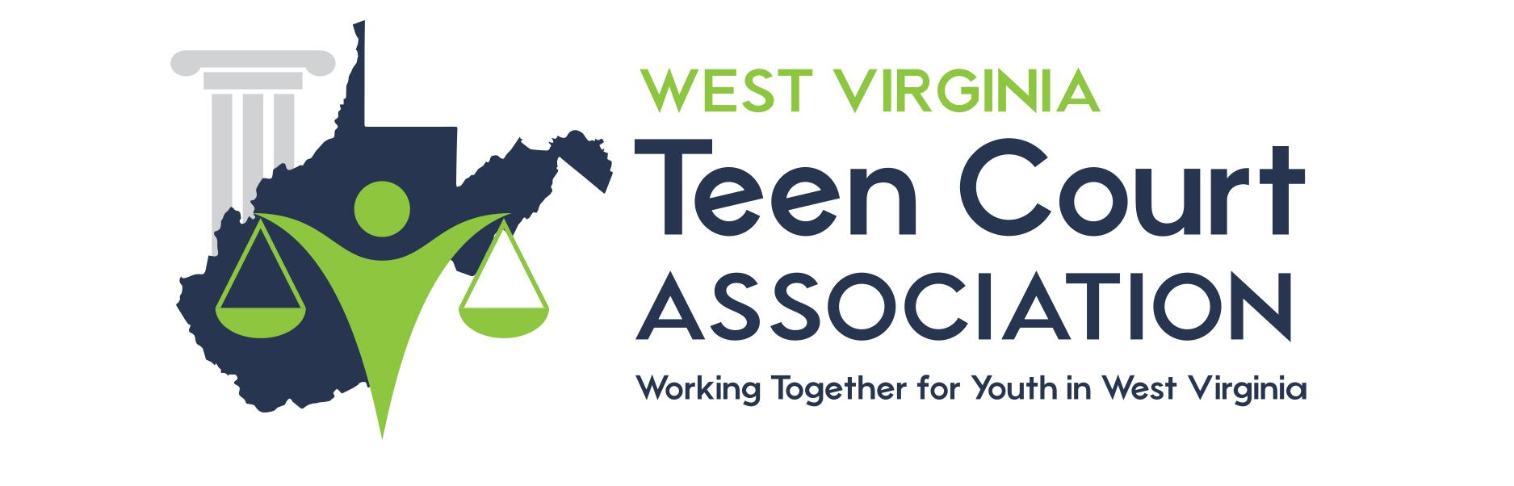

NO HELMET JUDGE’S SCRIPT

Have the clerk administer an oath to witness.

__(Defendant Name)_ You have been charged with a violation of the No Helmet law VC 21212. The law states that (a) A person under 18 years of age shall not operate a bicycle, a non motorized scooter, or a skateboard, nor shall they wear in-line or roller skates, nor ride upon a bicycle, a non motorized scooter, or a skateboard as a passenger, upon a street, bikeway, as defined in Section 890.4 of the Streets and Highways Code, or any other public bicycle path or trail unless that person is wearing a properly fitted and fastened bicycle helmet that meets the standards of either the American Society for Testing and Materials (ASTM) or the United States Consumer Product Safety Commission (CPSC), or standards subsequently established by those entities. This requirement also applies to a person who rides upon a bicycle while in a restraining seat that is attached to the bicycle or in a trailer towed by the bicycle.

How do you plead?

If “GUILTY” ask: Is this your first no helmet citation?

If “YES” say: The law allows that (d) Any charge under this subdivision shall be dismissed when the person charged alleges in court, under oath, that the charge against the person is the first charge against that person under this subdivision, unless it is otherwise established in court that the charge is not the first charge against the person.

At this point, I am dismissing your case. You must sign the Notice Of Warning, and view a Skateboarding Video. Please see the clerk at this time.

(Judge must also sign Warning Notice)

If “NO” then: Ask the defendant to be seated in the audience and move the case to the Master Jury to be heard and sentenced that evening.

If “NOT GUILTY” say: Please see the Teen Court Coordinator to have this case referred to the Juvenile Court process.

